**Cloud Computing: UE20CS352**

**Assignment 1 - Introduction to AWS Lambda with API Gateway**

**Naren Chandrashekhar, Section D**

**-PES2UG20CS216**

# 

# 1a: Lambda Function Created

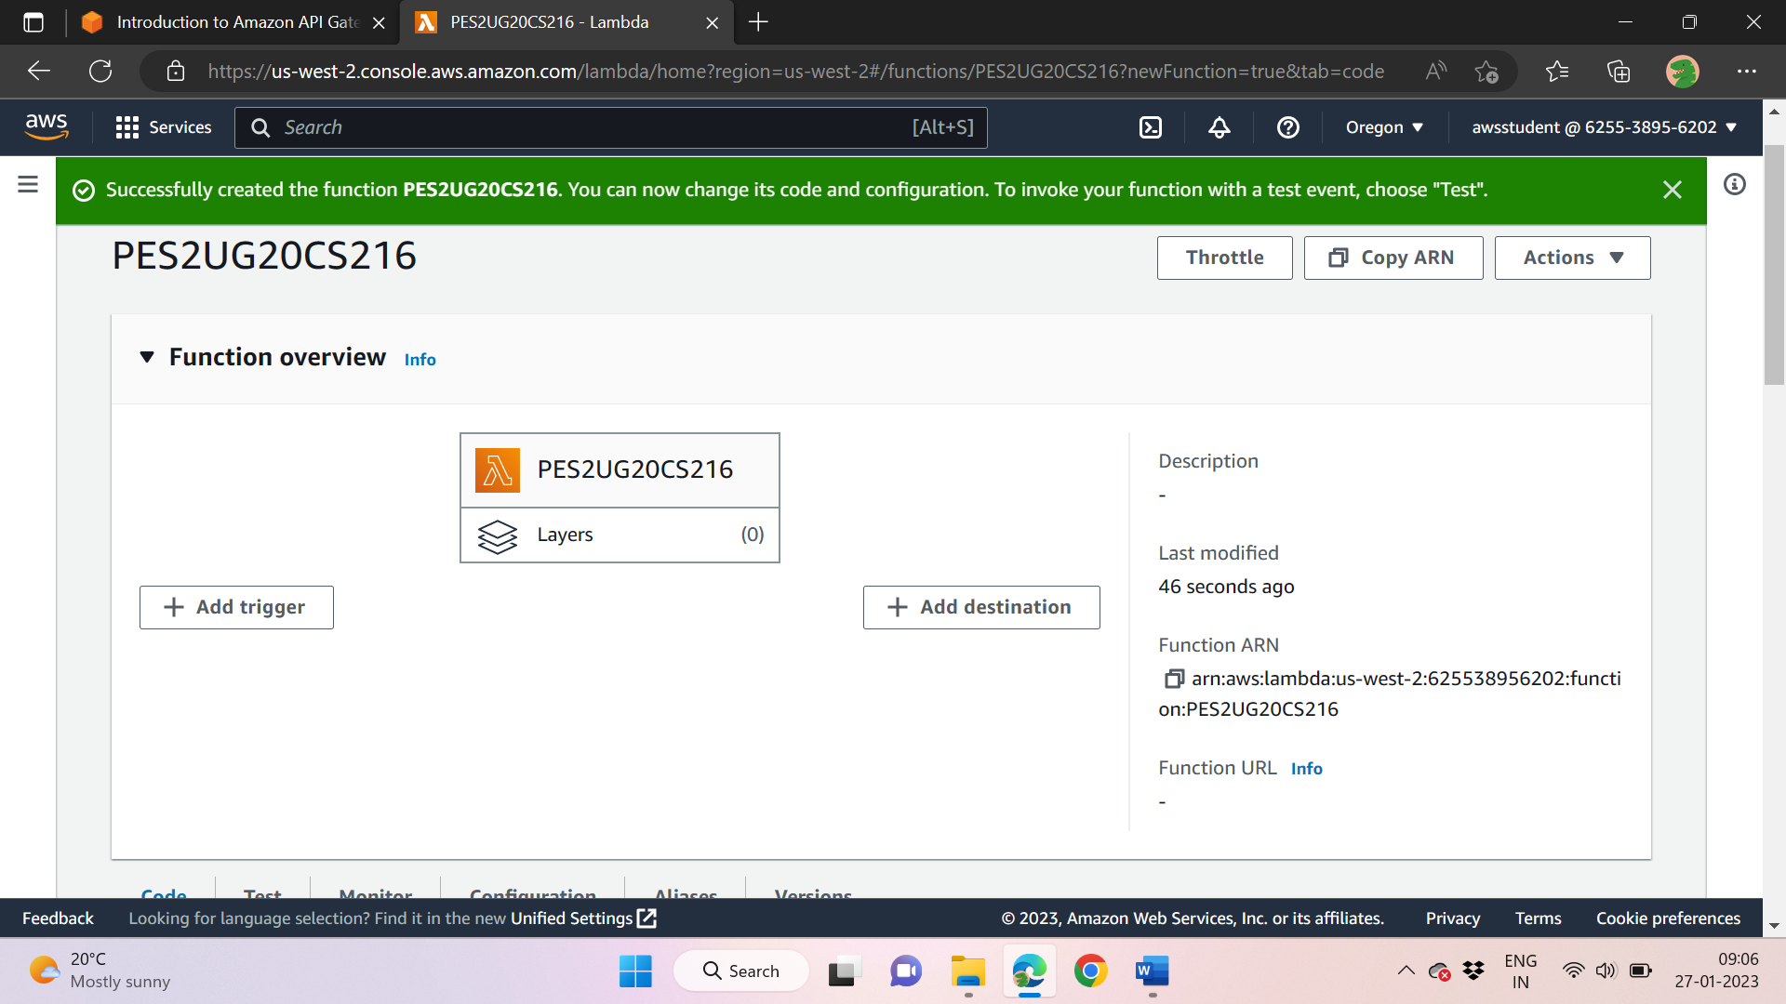

# 1b: API Gateway created, trigger added

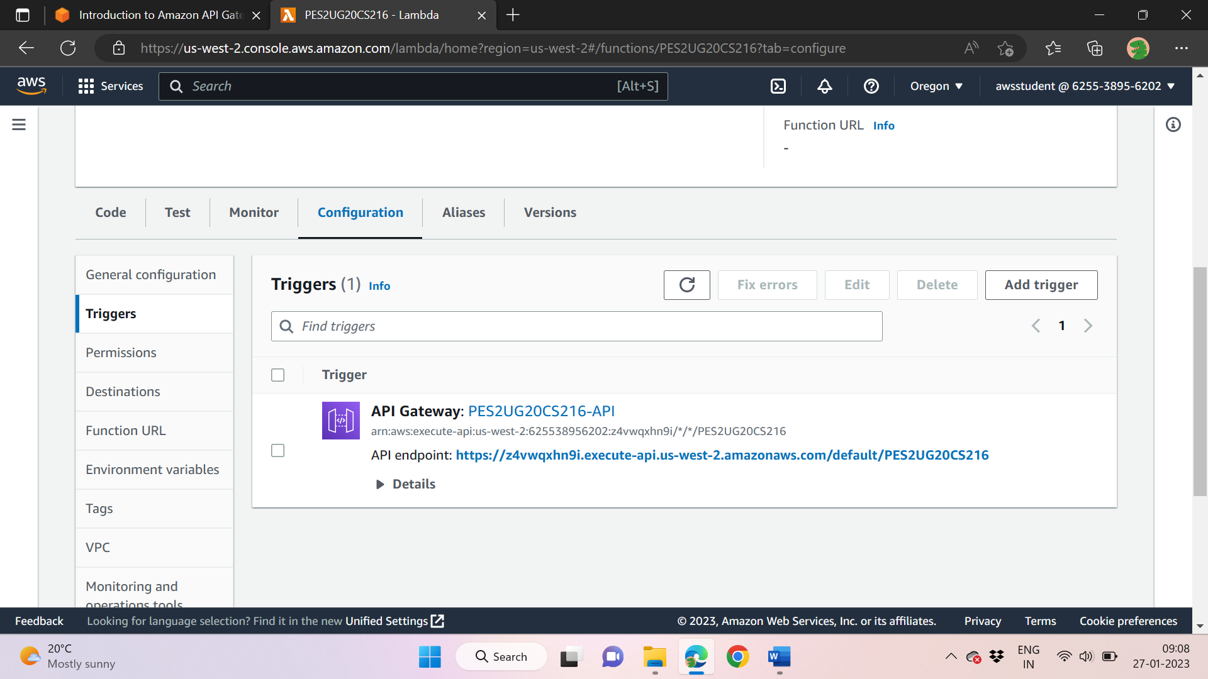

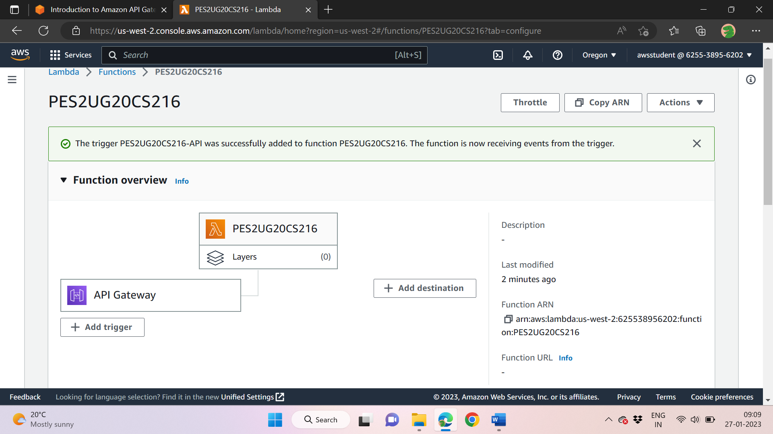

# 1c: Modified Lambda function

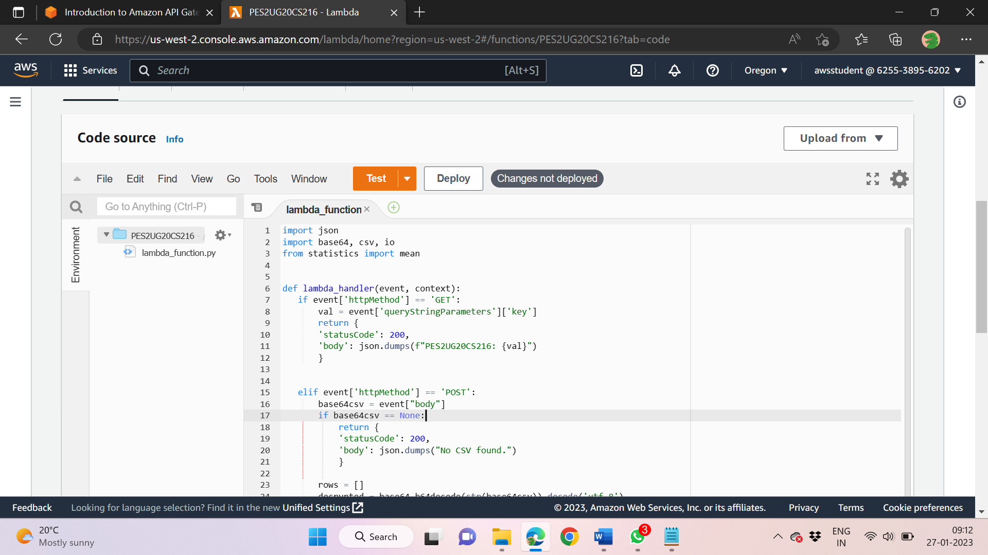

# 1d: Successful Postman GET request

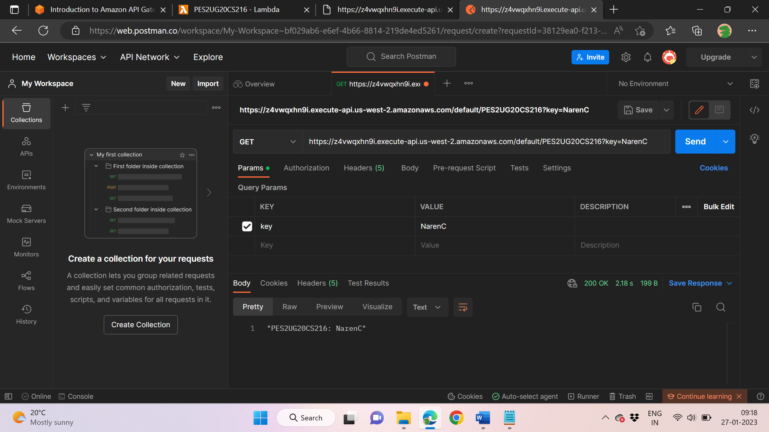

# 1e: Successful Postman POST request

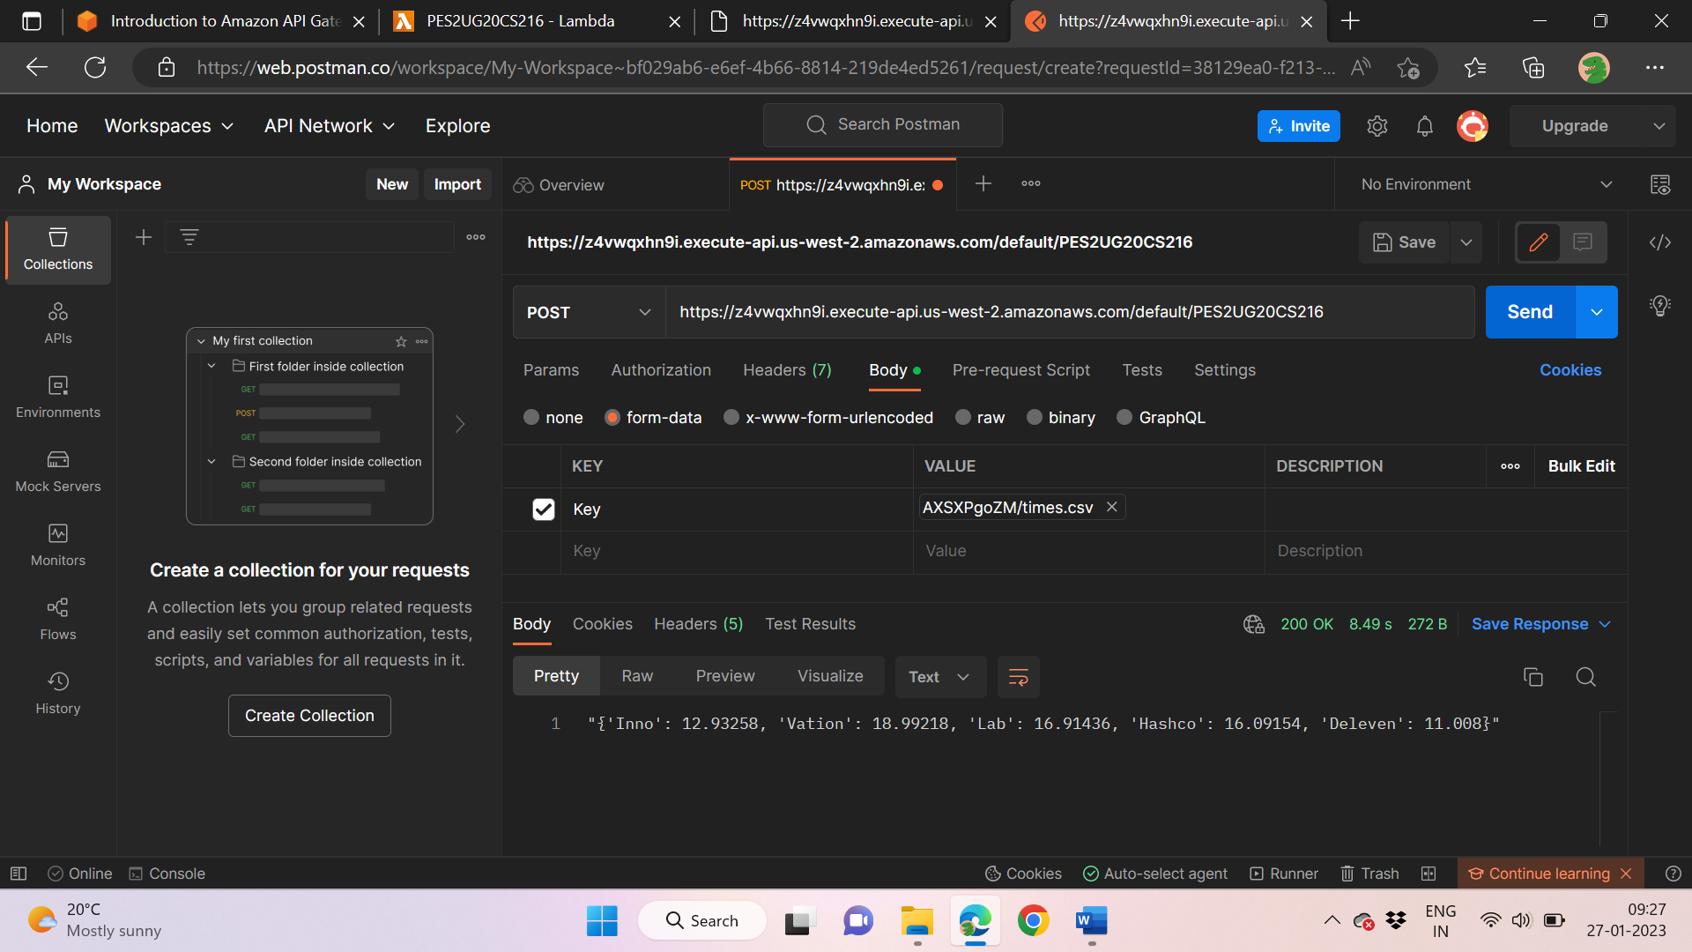

# 1f: Failed Postman PUT/DELETE/HEAD request

